NATUTAMA FOUNDATION
Summary of activities for 2019

Introduction
The central Amazon is a key area in the protection of biological and cultural diversity for the future. Because there are no roads to this area, the forest is far better preserved than it is in the Eastern Amazon (Brazil) and the Western Amazon (Peru and Ecuador). Fires are small, localized and controlled, limited to clearing areas for jungle gardens. Rainfall remains high and, though local people comment on change associated with climate, the whole region is a potential ‘reserve’. Tourism has brought substantial changes but it also provides an incentive to protect the forest and the rich biodiversity. Unfortunately, some tourist complexes are keeping animals in captivity – including a manatee - to entertain visitors

Until 2019, Puerto Nariño was located more than 200 metres up the river Loretoyacu, well sheltered from the strong currents of the river Amazon. But the island/peninsula that protected the mouth of the Loretoyacu has been washed away and soon the port may receive the full force of the Amazon, which now strikes the bank just below Natütama. The picture shows the town with boathouses opposite and Peru on the other side. Natütama is among the trees on the left, beyond the tourist pier.

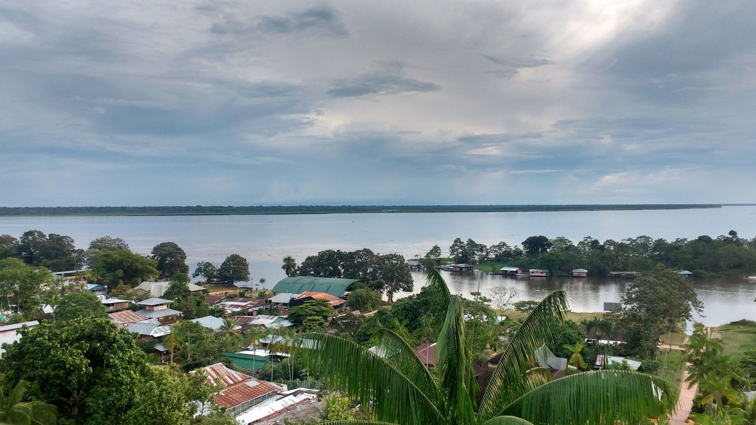

The Natütama Amazon team won an award in 2019 from the regional environmental authority (Corpoamazonia) for the best sustainable venture in the area; however, visitors to the Centre dropped in 2019 (see below).

Conservation and wildlife monitoring
In recent years all the islands and promontories on the Colombian side of the river Amazon near Puerto Nariño have been swept away. There are no protected backwaters for large aquatic animals in Colombian waters and only two nearby on the Peruvian bank. Because of this, as well as funding limitations, we have limited our manatee monitoring to the Tarapoto lake system, though our dolphin surveys cover both the lakes and the Amazon as before. Our monitoring results for 2019 were very encouraging.

Manatees
Natütama fishermen registered 119 manatee sightings in 2019 for the Tarapoto lakes. This is comparable with other years for the lakes and flooded forest, though the overall total was previously much higher due to river sightings during low water. The average number of manatees per sighting event (2.38) was also similar to past years, and 5 calves were seen in the Puerto Nariño area. This was reassuring for the future, particularly as a further 4 calves were registered upriver in the Atacuari area.

The water did not fall as far as usual in the low water season and at least 4 manatees stayed in Chepeten, one of the most distant lakes. More manatees than usual were registered for Chepeten and Cocha Largo in 2019 – this might be a response to the ever- increasing tourism in the lakes and/or to the lack of appropriate backwaters in the Amazon. There is also abundant vegetation in these lakes.

The Natütama fisherman in the Atacuari area recorded 126 manatee sightings for the lakes and the river Amazon, compared with 93 in 2018. He also registered the only hunting case for the region, at San Pablo in Peru. On another occasion he noted that manatee meat was on sale in the Peruvian town of Caballococha. He continues to visit communities in Peru with Natütama printed materials, including the Peruvian anti-hunting legislation, and has had considerable success in reducing hunting.

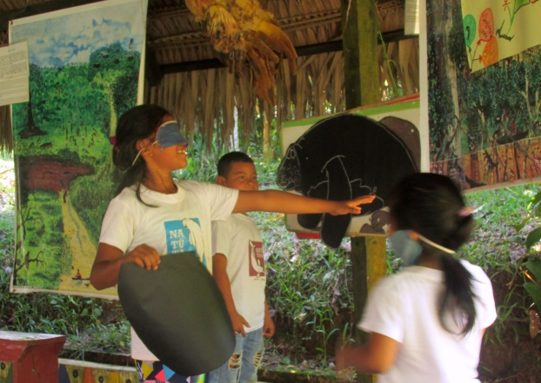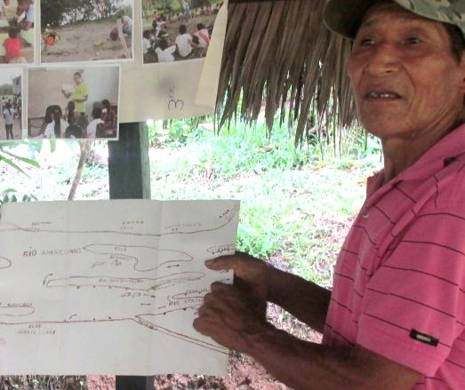
Putting the tail on the manatee at Natütama Atacuari fisherman with map

Dolphins
983 dolphin sightings were recorded on surveys in the river Amazon and Tarapoto lakes during 2019, slightly up on 2018, with an average of 20.5 dolphins sighted per survey segment. The maximum number of dolphins seen in one day (101) was the highest ever registered, boosted by large numbers of Sotalia in the river Amazon. More calves than usual were seen in the first part of the year, with 3 Inia and 5 Sotalia calves recorded on one full survey in March.

Although the maximum numbers of Inia and Sotalia in the Tarapoto lakes were comparable with other years, the overall numbers of dolphins using the lakes through the year was relatively low. This was unexpected, given that fishermen said that plenty of fish were available for feeding and the low water season was unusually short. In addition, the number of Inia registered in the inner lakes (not part of the ordinary survey) was very low (32) compared with recent years.

Inia sightings accounted for 39% of the total, marginally upon 2019 but still very low compared with previous years. However, the maximum number of Inia sighted on a single full survey is comparable with numbers registered for ten years ago. There were 7 dead dolphins registered in Peru and the Atacuari area where Peruvian fishermen continue to kill Inia that approach their nets.

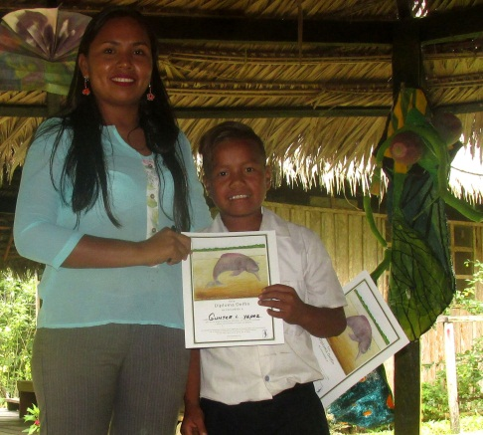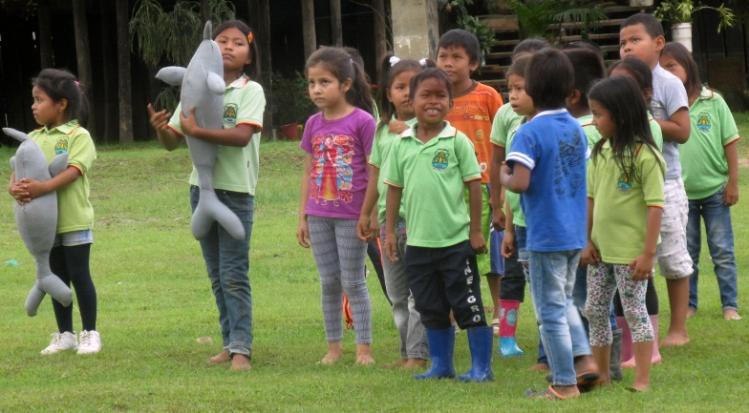
My dolphin diploma Children playing game - save the dolphins from nets

Sloths
The annual count of sloths in cotocaspi tree in February registered a record number for the Tarapoto channel (16). With more tourists looking for wildlife experiences, the sloth has come into its own and is valued by guides. There have been no further cases of sloths kept as pets in our area.

Other wildlife
Although we are no longer monitoring heron nests in the Ceiba trees, a
Natütama fisherman reported that there was a very big heron nesting
colony beyond the Umari lakes where we had previously kept count of the nests. Likewise, the Atacuari fisherman registered a large nesting colony.

We continued to focus on education for turtles rather than trying to monitor nesting, which now occurs mainly on Peruvian beaches. The turtle campaign targeted communities within reach of the beaches, especially on the Peruvian side of the river.

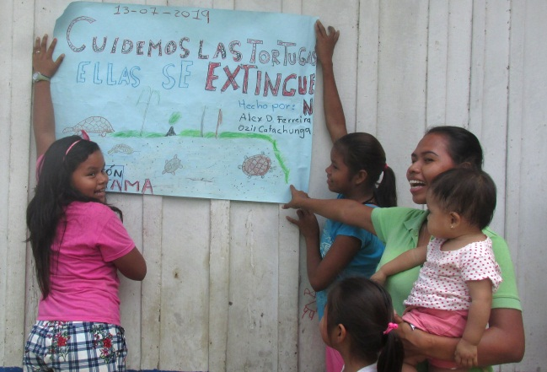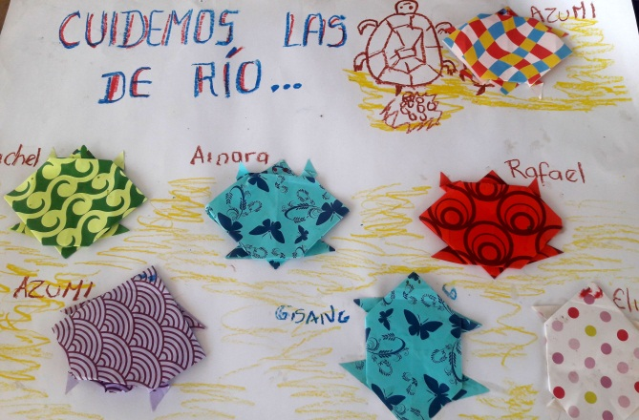

Education

The main theme for 2019 was “Where does our food come from?” Although this was the topic for Natütama Week in August, preparations began much earlier in the year with workshops involving indigenous elders, who discussed fishing, hunting and jungle gardens (chacras) with the educators. They revived stories, dances and the celebration of rites related to the origins of Ticuna agriculture and the importance of the chacra as an essential part of Ticuna culture. This is especially relevant for children, who now go to school instead of accompanying their parents and grandparents to the chacra.

The children in 1st to 5th grades worked towards diplomas representing animals that are endangered locally – the river dolphin, manatee, pirarucú fish, turtles – and the giant Ceiba tree. They all visited the Natütama Interpretation Centre for a morning’s activities centred on the underwater world. Each grade has a different programme, and the overall programme is designed to cover most aspects of the natural world, from insects to the solar system and sacred places for animals.

Three junior ecology groups complemented this programme, with the emphasis on more practical aspects of caring for the environment. Two of the groups re-forested the banks of streams in their communities and the third worked on medicinal plants with elders. All three groups took part in recycling activities, such as making dolphins from plastic bottles, and prepared special presentations for Natütama Week.

Summary of children’s groups covered by the project
In all, 658 children took part in school classes, ecology groups and community education activities:

Group | Age of children | No. of children | Location | Frequency
Pre-school kindergartens | 1 – 4 years | 50 | Puerto Nariño area | One day
Pre-school grades school | 5 – 6 years | 69 | Puerto Nariño & San Francisco | 10 workshops each grade
1st & 2nd grades of school | 6 – 7 years | 175 | Puerto Nariño &  San Francisco | 10 workshops each grade
3rd, 4th, 5th grades of school | 8 -12 years | 247 | Puerto Nariño & San Francisco | 10 workshops each grade
Junior ecology group | 4 – 9 years | 30 | Puerto Nariño | weekly
Junior ecology groups (two) | 4-10 years | 30 | Puerto Esperanza & Aticoya | fortnightly
Junior school | 6-12 years | 20 | Vergel community | One day
Peruvian  Communities | 5-12 years | 37 | San Antonio & Reubicación | Two days
Total number of children |  | 658

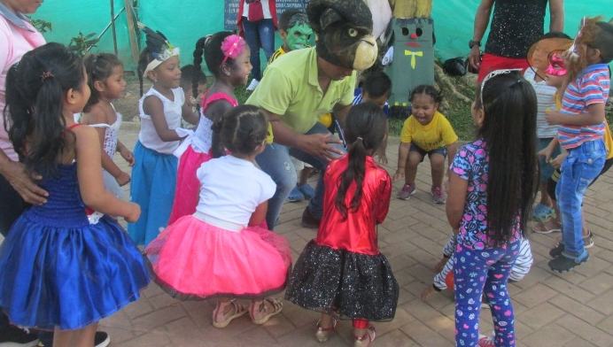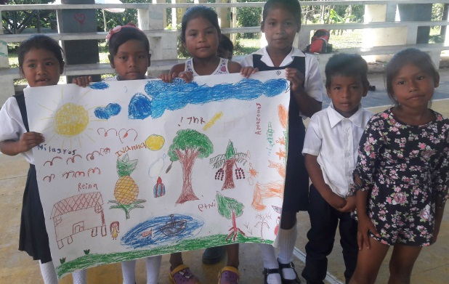
Monkey fun for the youngest children What grows in our chacra

There were four days of activities for the whole community during Natütama Week. These included games related to fish and manioc, making clay models of the animals found in the chacra, paintings related to the theme of the origin of food, a play about the chacra and songs and dances.

The Natütama educators carried out a workshop for local educators who work with small children in the pre-school centres, reinforcing strategies for strengthening the bond between children and their environment.
In addition, the Rudolf Steiner specialist from Cali who designed the Natütama education programme went to Puerto Nariño for 3 weeks of workshops with the educators to update and reinforce pedagogical methods.
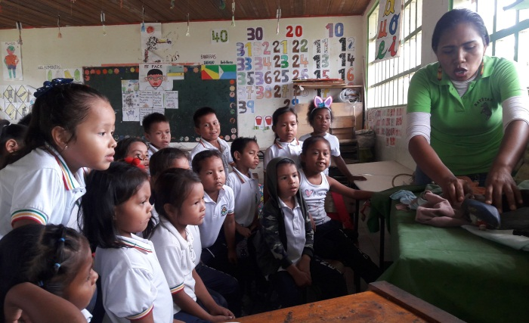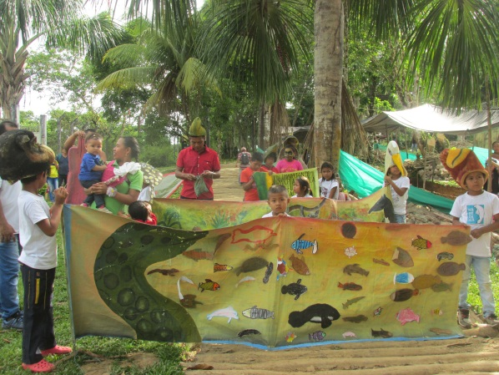
Story telling in class Preparing Natütama Week parade

The Natütama Centre
There was a substantial drop (-19.4%) in the number of people visiting the Centre in 2019, with a total of 5.321 visitors. The main reason for this poor result was the disintegration of both the bridges connecting the Centre to the village and the steps allowing access from the river bank. The younger children could not visit the Centre and our most important agency stopped bringing visitors from September, when the bridges were taken down to avoid any accidents. The wood for rebuilding was delayed and the bridges were only finished in mid-December.

Although we have been told the agency will go ahead with visits in 2020, the loss of income was sorely felt in what has been a difficult financial year. We have reduced our outgoings as much as possible while still keeping the education and the monitoring programmes running. We shall be trying to raise some extra funding to make the 15th anniversary of Natütama Week an outstanding celebration involving the whole community in exploring Ticuna origins and the future for people, wildlife and the forest in the area. The conservation coordinator has written a book about community conservation of manatees and we would like to try and obtain funding for Natütama to publish this in time for the 15th anniversary.

The Natütama team 2019
Director: Clara Ximena Torres
Education adviser: Diana Luz Orozco
Conservation coordinator: Sarita Kendall
Centre and monitoring coordinator: Edgar Pinto
Education coordinator in the Amazon: Marelvi Laureano

Selvando educators and Centre guides: Saul Coello, Marelvi Laureano, Karina Laureano, Edgar Pinto, Omar Lopez, Rodolfo Macedo, Linder Napuche, Nafer Niño, Yamile Caparro.
Coinvestigators: Casimiro Ahue, Pedro Ahue, Jesus Uriel Peña, Luis Hernando Peña, Luis Ahuanari.
Elders: Julia Gomez, Valentina del Aguila, Alba Lucia Cuellar, Alicia Cuellar, Angelica Ahue, Roque Ahue, Eugenio Coello, Pastora Guerrero, Emiliano Pinedo
Legal affairs and accounting: Cesar Hernandez, Alejandro Ruiz

With special thanks for continuing support:
Children of Colombia, Lindsay Foundation, Othmar-Bamert-Stiftung- Lucerne, Whale & Dolphin Conservation, Peter Gerstrom, Nicholas Morris, Brian Moser, Beatriz Vejarano, Sally Wilson, Alison Wood, contributors at the Periana flea market.

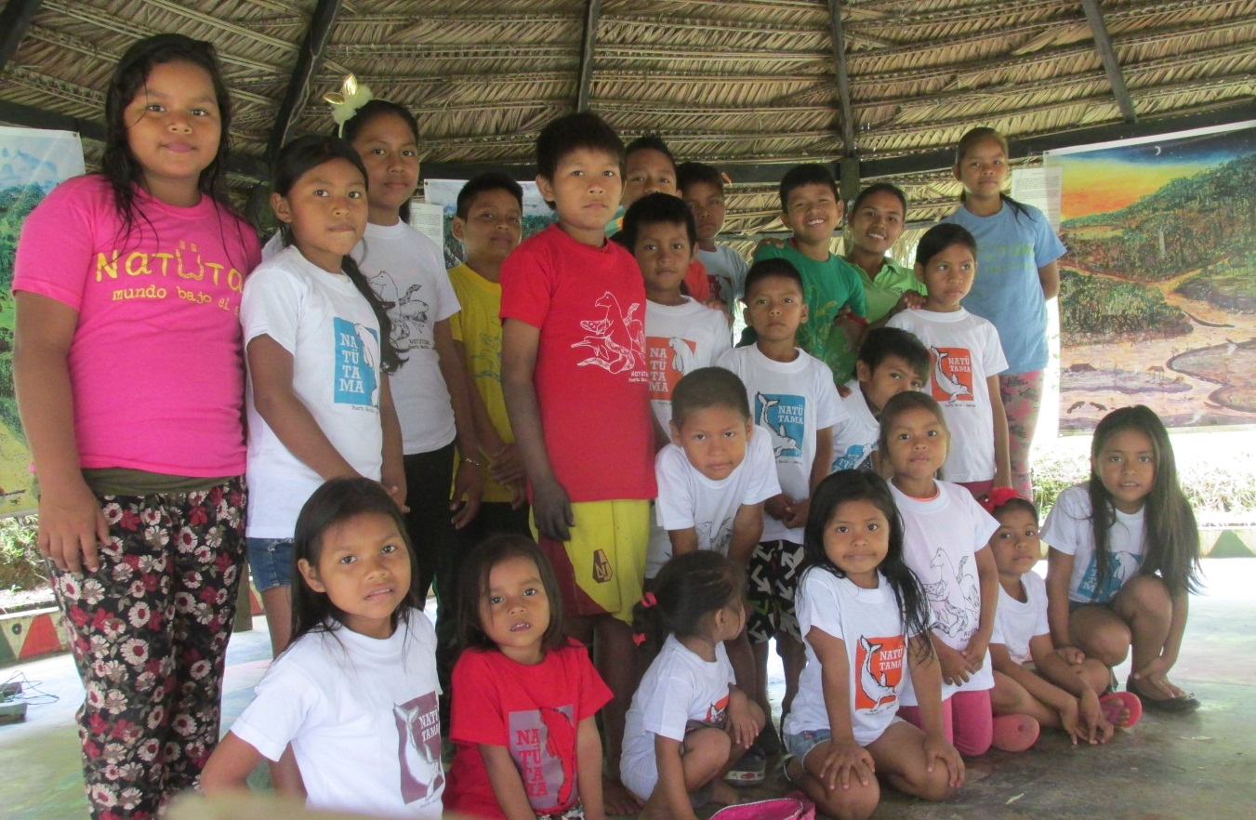
Junior ecology group at the Natütama Centre

